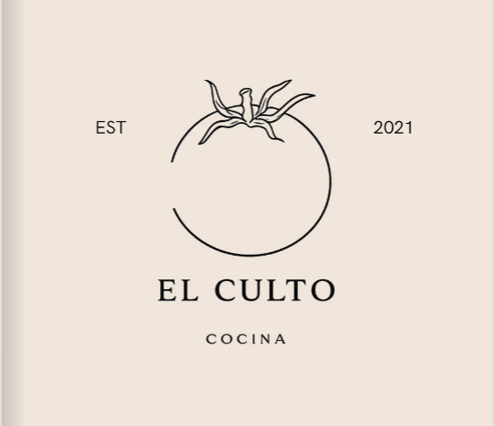
EL CULTO COCINA
Brand Brief & Website Content Reference
Cocina de Autor con sabor a México · Envigado, Antioquia
“Sabores que despiertan memorias”
Prepared for website development · June 2026
Source material: brand menu, Instagram (@culto_cocina) and provided assets

What's inside
- Brand snapshot (key facts)
- Identity & positioning
- Brand story (ES / EN)
- Philosophy & manifesto (ES / EN)
- Brand voice & messaging
- Visual identity (logo, colors, type, motifs)
- Full menu (all sections, prices in COP)
- Contact, hours & location
- Audience & atmosphere
- Website recommendations
- Brand assets & where to get photography
- Sources & notes

Brand snapshot
Quick-reference facts to seed the website's header, footer, contact page and metadata.
Name | El Culto Cocina (styled EL CULTO COCINA; also “Culto Cocina”)
Founded | 2021 (“EST 2021”)
Concept | Mexican author cuisine (cocina de autor) — fresh ingredients, authentic recipes, table service
Tagline | Sabores que despiertan memorias (“Flavors that awaken memories”)
Bio line | Cocina de Autor con sabor a México
Location | Envigado, Antioquia, Colombia (Medellín metro)
Address | Reported as Calle 46 Sur # 46A-01, Envigado — please confirm before publishing
Hours | Sun–Thu 2:00 PM – 10:00 PM · Fri–Sat 2:00 PM – 10:45 PM
WhatsApp / Orders | +57 323 319 6133 (delivery — “Pide tu domicilio”)
Instagram | @culto_cocina · ~2,408 followers · 113 posts
Chef / Founder | @zuluaga_chef (Chef Zuluaga) — signs the menu as “Chef y Fundador”
Online menu | Digital flipbook menu
Currency | Colombian Peso (COP). Prices shown e.g. $9.500 = COP 9,500
Service modes | Dine-in (table service) and delivery / takeout via WhatsApp

Identity & positioning
El Culto Cocina is a Mexican author-cuisine restaurant in Envigado, in the Medellín metropolitan area. The name plays on the idea of “un culto a la comida” — a devotion or cult to food — with Mexican origin at its heart. The positioning blends two ideas the brand returns to constantly: authentic, vibrant Mexican flavor, and a calm, restorative dining ritual where the guest is cared for.
What it stands for: fresh ingredients, authentic recipes, high-quality products and real table service — elevated to an emotional, sensory experience rather than just a meal.

Positioning statement (suggested)
For diners in Envigado and Medellín who crave authentic Mexican flavor, El Culto Cocina is an author-cuisine restaurant that turns every visit into a warm, sensory ritual — vibrant Mexican recipes, fresh ingredients and attentive table service, in a lively yet caring atmosphere.

Core themes to carry into the site
- Devotion to food: The brand is literally framed as a “culto” (devotion) to Mexican cuisine.
- Memory & emotion: Flavors that awaken memories; an emotional, sensory experience “en cada bocado.”
- Authenticity & craft: Authentic recipes, slow-cooked meats, house-made salsas and “de la casa” preparations.
- Care & restoration: “Restaurar” = to restore: a place that reminds you that you also deserve to be cared for.
- Festive Mexican spirit: Color, chiles, papel picado and celebration — balanced with an elegant, minimal core identity.

Brand story
From the menu's opening page — use as About copy, web hero subtext, or social bio source.

Español (verbatim)
“Nacimos en 2021, y como su nombre lo indica, es un culto a la comida con origen mexicano, donde se vive una experiencia de sabores con ingredientes frescos y recetas auténticas, productos de alta calidad y servicio a la mesa. En Culto Cocina transmitimos una emoción sensorial en cada bocado, a través de nuestras técnicas culinarias, colores y sabores vibrantes de México. Disfruta de una fiesta de sabores que deleitarán todos tus sentidos.”

English (translation)
“We were born in 2021 and, as the name suggests, we are a cult to food of Mexican origin — an experience of flavors built on fresh ingredients and authentic recipes, high-quality products and true table service. At Culto Cocina we convey a sensory emotion in every bite, through our culinary techniques and the vibrant colors and flavors of Mexico. Enjoy a feast of flavors that will delight all of your senses.”

Philosophy & manifesto
From the closing page of the menu, signed by the Chef & Founder. Ideal for an “Our philosophy” section.

Español (verbatim)
“El restaurante Culto Cocina viene del acto de restaurar: regresar a lo esencial, recomponer el alma y honrar el momento presente. Aquí no solo se viene a comer; se viene a detener el tiempo, a sentarse con uno mismo y a elegir el amor propio como ingrediente principal.
Nuestro compromiso no se centra en lo llamativo, sino en el trabajo cuidadoso que garantiza calidad en cada preparación; creemos que lo verdaderamente valioso se expresa con espontaneidad. Nuestro propósito es honrar la calidad, el sabor bien elaborado y los platos que nutren el cuerpo y reconfortan el alma.
Porque a veces, lo único que necesitamos es una mesa, un buen plato… y un lugar que nos recuerde que también merecemos ser cuidados.”
— Chef y Fundador (@zuluaga_chef)

English (translation)
“The restaurant Culto Cocina comes from the act of restoring: returning to the essential, mending the soul and honoring the present moment. Here you don't only come to eat; you come to stop time, to sit with yourself and to choose self-love as the main ingredient. Our commitment is not about what is flashy, but about the careful work that guarantees quality in every preparation; we believe that what is truly valuable is expressed with spontaneity. Our purpose is to honor quality, well-crafted flavor and dishes that nourish the body and comfort the soul. Because sometimes, all we need is a table, a good plate… and a place that reminds us that we, too, deserve to be cared for.”

Brand voice & messaging
The voice is warm, sensory and a little poetic — it speaks about emotion, memory and care as much as about food. It is celebratory (“una fiesta de sabores”) yet grounded and sincere, never flashy. Spanish is the primary language; a light, confident bilingual touch works for a wider audience.

Tone in three words
Warm · Sensory · Authentic.

Do
- Lead with feeling and the senses (sabores, memorias, emoción, reconfortar).
- Celebrate Mexican origin, color and craft — chiles, recetas auténticas, “de la casa.”
- Use the language of care and ritual (detener el tiempo, ser cuidados).
- Keep Spanish primary; keep sentences inviting and unhurried.

Don't
- Sound corporate, hype-y or discount-driven — it clashes with the calm, crafted positioning.
- Over-explain or use heavy jargon; let the food and feeling lead.
- Lose the festive warmth by going too minimal/cold.

Ready-to-use lines
- “Sabores que despiertan memorias.”
- “Un culto a la comida con origen mexicano.”
- “Una fiesta de sabores que deleitan todos tus sentidos.”
- “Cocina de autor con sabor a México — ingredientes frescos, recetas auténticas.”
- “Detén el tiempo y elige el amor propio como ingrediente principal.”

Visual identity

Logo
A minimal, elegant mark: a single-line illustration of a tomato enclosed in a thin circle, flanked by “EST” and “2021,” above an all-caps serif wordmark “EL CULTO” with “COCINA” as a spaced sub-label. It sits on a warm cream field. Keep generous clear space; use the dark ink version on cream/light backgrounds and a reversed cream version on dark/photographic backgrounds.

Color palette
The core identity is cream + ink; the festive Mexican accents (green, chili red, terracotta, corn gold) come from the brand's photography and menu graphics. Hex values are drawn directly from the supplied logo and content image.
Color | HEX | RGB | Uso sugerido
Lino (Cream) | #F0E6DC | 240, 230, 220 | Primary background / canvas
Tinta (Ink) | #1C1B19 | 28, 27, 25 | Text, logo, footers
Verde Culto | #0E6E2E | 14, 110, 46 | Primary accent, headings, buttons
Rojo Chile | #9A2B1E | 154, 43, 30 | CTAs, highlights, prices
Barro (Terracotta) | #C2702F | 194, 112, 47 | Secondary accent / warmth
Maíz (Gold) | #EFC25E | 239, 194, 94 | Highlights, dividers, hover

Typography
Display / headings: an elegant high-contrast serif. Web-safe matches: Playfair Display or Cinzel for the wordmark feel, with Lora as a versatile alternative.
Body / UI: a clean, friendly sans such as Poppins (used in the accompanying style sheet) or Montserrat for menus, captions and buttons.

Motifs & graphic language
- Line-art tomato (from the logo) — a simple, repeatable brand icon.
- Papel picado banners, sombreros and chiles — festive Mexican accents used across the menu.
- Elegant serif headers on cream, with small decorative borders.
- Vibrant, close-up food photography as the main visual energy.

Spice-level system (“Nivel de picante”)
The menu marks heat with a chili icon. Carry this onto the site as a small legend:
- ● Picante fuerte — Strong / hot
- ● Picante medio — Medium
- ● Ligeramente picante — Mild
- ● Mermelada dulce — Sweet (house jam)

Brand style guide (one-pager)
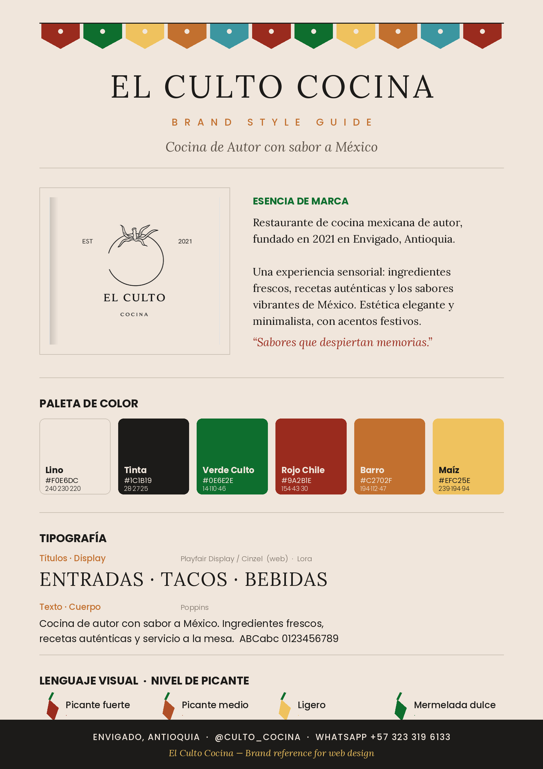

Full menu
Complete menu transcribed from the brand's digital flipbook. Prices in Colombian Pesos (COP). Use as the source of truth for the site's menu section and any ordering integration.

Entradas (Starters)
Plato | Precio (COP) | Descripción
Guacamole | $29.000 | Guacamole de la casa acompañado de nachos, pico de gallo, carne de cochinita pibil, queso blanco, sour cream, piña asada, cilantro y mermelada de jalapeño de la casa.
Ceremonia de Nachos | $18.000 | Nachos bañados en mermelada de la casa, cilantro, guacamole de la casa y sour cream.
Sopa Birriera | $22.900 | Caldo en cocción de especias y chiles, acompañado de carne de res desmechada, pico de gallo, aguacate, cilantro, limón, tortilla de maíz o nachos.
Elote | $19.500 | Mazorca dulce desgranada, salteada en mayonesa de chipotle, sour cream, queso blanco, tajín y cilantro.
Tacos Dorados | $27.900 | 4 flautas rellenas de puré de papa y carne al pastor, guacamole de la casa, sour cream y queso blanco.

Tacos
Tacos are priced individually unless noted; the Trío and Combo are sharing/value options.
Plato | Precio (COP) | Descripción
Cochinita Pibil | $9.500 | Tortilla de maíz, carne cochinita pibil, guacamole, encurtido yucateco y cilantro.
Al Pastor | $9.900 | Tortilla de maíz, carne al pastor, piña asada, cebolla blanca y cilantro.
Arrachera | $9.900 | Tortilla de maíz, carne de res marinada en arrachera, guacamole, pico de gallo y puntos de salsa de frijol refrito y cilantro.
Morrillo | $10.000 | Tortilla de maíz, carne de morrillo cocinada en chiles y cerveza, puré de plátano y chipotle, guacamole, pico de gallo, sour cream y cilantro.
Chori-Taco | $10.500 | Tortilla de maíz, chorizo gourmet, pico de gallo, puntos de sour cream y salsa de frijol refrito.
Taco de Pollo | $10.500 | Pollo apanado en finas hierbas, tortilla de maíz y panko, encurtido yucateco, guacamole, sour cream, mayonesa de chipotle y cilantro.
Taco de Camarón | $11.900 | Camarón apanado en cítrico y panko, tortilla de maíz, guacamole de la casa, encurtido de rábano y flor de jamaica, mayonesa de chipotle, sour cream y cilantro.
Taco de Lengua | $10.500 | Tortilla de maíz, lengua de res en cocción lenta, cebolla blanca, salsa verde de la casa y cilantro.
Trío de Tacos Birrieros | $36.000 | Tortilla de maíz, res desmechada en cocción lenta con chiles y especias, costras de mix de quesos, cebolla blanca, cilantro y caldo de birria.
Combo Tacos | $33.000 | 3 unidades de tacos a elección (arrachera, cochinita pibil, al pastor), adición de nachos y mermelada de jalapeño + gaseosa Postobón 250 ml.

Platos Fuertes (Mains)
Plato | Precio (COP) | Descripción
Quesadilla de Pollo | $31.900 | Tortilla de harina, mix de queso, pollo desmechado, mermelada de jalapeño, pico de gallo, puntos de guacamole, sour cream, salsa de frijol refrito y cilantro; acompañada de nachos y mermelada de jalapeños.
Quesadilla al Pastor | $33.900 | Tortilla de harina, mix de quesos, carne al pastor, cebolla blanca, mayonesa de chipotle, puntos de guacamole, sour cream y cilantro; acompañada de nachos.
Quesadilla Mixto | $36.900 | Dos carnes a elección (pastor, cochinita, arrachera, morrillo, lengua de res o pollo), tortilla de harina, mix de quesos, cebolla blanca, mayonesa de chipotle, guacamole, sour cream y cilantro; acompañada de nachos.
Burrito de Cochinita | $28.900 | Tortilla de harina, guacamole, pico de gallo, sour cream, carne cochinita pibil, lechuga romana, salsa verde de la casa y queso blanco; acompañado de nachos y mermelada de jalapeños.
Burrito Mixto | $34.900 | Doble carne a elección (pastor, cochinita, arrachera, morrillo, lengua o pollo), tortilla de harina, guacamole, pico de gallo, sour cream, lechuga romana, salsa verde de la casa y queso blanco; acompañado de nachos y mermelada de jalapeños.
Chilaquiles | $28.900 | Tortilla de maíz crocante, carne de arrachera, salsa verde de la casa, queso blanco, pico de gallo, sour cream, huevo frito, cilantro y guacamole de la casa.
Hamburguesa | $35.900 | Pan brioche, carne de res hecha en casa, mayonesa chipotle, tocineta, queso cheddar, cebolla caramelizada en agraz, sour cream y cogollo; acompañada de papas a la francesa o nachos.
Hamburguesa Doble Carne | $45.900 | Pan brioche, doble carne de res hecha en casa, mayonesa chipotle, tocineta, doble queso cheddar, cebolla caramelizada en agraz, sour cream y cogollo; acompañada de papas a la francesa o nachos.
Papas Cochinas | $28.900 | Papas a la francesa, papa criolla, guacamole de la casa, carne de cochinita pibil, sour cream, queso blanco, nachos y cilantro.
Caserola de Nachos | $39.000 | Nachos, guacamole de la casa, pico de gallo, sour cream, salsa de frijol refrito, queso blanco, carne de cochinita pibil, mermelada de jalapeño y cilantro.
Chimichanga | $34.000 | Tortilla de harina frita rellena de mix de queso, carne de morrillo salteada con pimentón, pico de gallo, bañada en guacamole de la casa, queso blanco, sour cream y cilantro.
Bowl Mexicano | $27.900 | Lechuga romana en chiffonade, salsa verde de la casa y mermelada de jalapeño, elotes con sour cream, tajín y queso blanco, pico de gallo, láminas de aguacate, crispetas de pollo en finas hierbas y nachos.
Elote con Pollo | $25.000 | Mazorca dulce desgranada salteada en mayonesa de chipotle, pollo, sour cream, queso blanco, tajín y cilantro.
Torta Pibil | $28.000 | Pan brioche bolillo, guacamole, queso blanco, tomates asados, mayonesa de chipotle, sour cream, carne de cochinita pibil, encurtido yucateco, piña asada y salsa verde de la casa; acompañada de nachos.
Dorilocos | $28.500 | Doritos acompañados de pollo desmechado, tocineta, maíz dulce, dados de plátano maduro, lechuga en chiffonade, pico de gallo, sour cream, salsa verde de la casa, queso blanco y cilantro.
Tostadas de Arrachera | $26.500 | Tostadas de maíz, carne de arrachera, guacamole, sour cream, mayonesa de chipotle, salsa de frijol refrito, pico de gallo, queso blanco y cilantro.
Tacada (para compartir) | $94.900 | 2 tacos al pastor, 2 tacos de cochinita pibil, 3 tacos de arrachera, 3 tacos dorados, guacamole, nachos, porción de carne de cochinita pibil, salsa verde de la casa, sour cream y mermelada de la casa.

Para los Verdi-Lovers (Vegetarian)
Plato | Precio (COP) | Descripción
Burrito Veggie | $28.000 | Tortilla de harina, guacamole, pico de gallo, sour cream, champiñones crujientes, salsa de frijol refrito, lechuga romana, salsa verde de la casa y queso blanco; acompañado de nachos.
Caserola de Nachos Veggie | $36.900 | Nachos, guacamole, pico de gallo, sour cream, salsa de frijol refrito, champiñones crujientes, queso blanco, mermelada de jalapeño y cilantro.
Taco Veggie | $10.500 | Tortilla de maíz, guacamole, champiñones crujientes, encurtido yucateco, puntos de sour cream y cilantro.
Quesadilla Veggie | $28.000 | Tortilla de harina, mix de quesos, champiñones crujientes, salsa de frijol refrito, mermelada de jalapeño, pico de gallo, guacamole, sour cream y cilantro; acompañada de nachos.
Papas Veggie | $29.000 | Papas a la francesa y criolla en doble fritura, guacamole, champiñones crujientes, salsa de frijol refrito, pico de gallo, sour cream, queso blanco, nachos y cilantro.
Hamburguesa Veggie | $33.900 | Pan brioche, carne de lentejas, queso cheddar, mayonesa chipotle, cebolla caramelizada en agraz, sour cream y cogollo; acompañada de papas a la francesa o nachos.

Bebidas (Drinks)
Plato | Precio (COP) | Descripción
Agua de Jamaica | $6.000
Gaseosa Postobón | $3.500
Coca-Cola | $5.500
Té Hatsu | $7.500
Soda Hatsu | $6.500
Soda Bretaña | $4.500
Agua Hatsu | $5.500
H2O 600 ml | $6.000
Cerveza Costeñita | $5.000
Cerveza Nacional (Pilsen / Águila / Águila Light) | $5.500
Cerveza Coronita 210 ml | $6.500
Cerveza Club Colombia | $7.500
Cerveza Corona 330 ml | $8.500
Cerveza Sol | $8.500
Cerveza Modelo | $12.000
Soda Michelada (Lychee / Cereza / Maracuyá) | $15.000
Vaso Michelado | $3.000

Licores (Spirits & Cocktails)
Plato | Precio (COP) | Descripción
Shot de Tequila — Cuernavaca | $7.500
Shot de Tequila — Jimador | $10.000
Margarita | $25.000
Note: one main — Hamburguesa Doble Carne — had its final price digits hidden in the page fold; listed as $45.900 to match the menu's consistent “.900” pattern. Worth confirming.

Contact, hours & location
City | Envigado, Antioquia, Colombia (Medellín metropolitan area)
Address | Reported as Calle 46 Sur # 46A-01, Envigado — confirm exact address/Google Maps pin before publishing
Hours | Sunday–Thursday: 2:00 PM – 10:00 PM
 | Friday–Saturday: 2:00 PM – 10:45 PM
WhatsApp / Orders | +57 323 319 6133
Instagram | instagram.com/culto_cocina
Digital menu | heyzine.com/flip-book/a399c34ab4.html

Suggested contact CTAs for the site
- “Pedir por WhatsApp” button → https://wa.me/573233196133
- Click-to-call and an embedded Google Map pin
- Hours block in the footer and on a Contact page
- Instagram feed/link as social proof

Audience & atmosphere
The restaurant draws locals and food lovers across Envigado and greater Medellín who are looking for authentic, vibrant Mexican food in a relaxed but characterful setting. It serves both sit-down diners (table service is part of the promise) and delivery/takeout customers via WhatsApp.
Atmosphere: the venue reads as a lively, colorful Mexican space — outdoor patio energy with street-art murals, papel picado, plants and warm string lighting (as featured in the “Ubicación” Instagram highlight). The website should pair that festive, photogenic warmth with the elegant, minimal logo and cream palette so it feels crafted rather than kitschy.

Content themes on Instagram
- Close-up plated dishes (tacos, nachos, guacamole, drinks).
- Reels from the kitchen / bar and the dining space.
- Customer moments (“Clientes” highlight).
- Location & hours (“Ubicación”), and the menu (“Menu” highlight linking to the flipbook).

Website recommendations
Suggested structure and content mapping, drawn from everything above. Spanish-first, with optional English.

Suggested pages / sections
- Home / Hero: Logo on cream or over a vibrant food photo; tagline “Sabores que despiertan memorias”; primary CTAs: Ver menú · Pedir por WhatsApp.
- Menú: The full menu by section (use the tables in this doc); spice-level legend; prices in COP; link to the flipbook as a fallback.
- Nosotros / Filosofía: Brand story + manifesto (provided in ES/EN), signed by the chef.
- Galería: Food and venue photography (see photo sources below).
- Visítanos / Contacto: Address + Google Map, hours, WhatsApp button (wa.me/573233196133), Instagram.
- Pedir / Domicilios: WhatsApp ordering CTA and any delivery-app links.

Conversion & UX notes
- Make “Pedir por WhatsApp” a persistent, high-contrast button (Rojo Chile or Verde Culto).
- Show hours and location prominently — a common first question for a restaurant.
- Lead with strong food photography; keep chrome minimal and on the cream palette.
- Mobile-first: most traffic will come from the Instagram link in bio.

SEO starting points (ES)
- restaurante mexicano Envigado
- comida mexicana Envigado / Medellín
- tacos en Envigado
- cocina de autor mexicana Medellín
- domicilios comida mexicana Envigado

Brand assets & where to get photography
Assets included in this Brand_assets folder:
- Culto_Brand.png — The primary logo (line-art tomato + wordmark) on cream.
- Culto_content.png — “Pide tu domicilio” delivery flyer with food photography and the orders number.
- Culto_Brand_Style_Guide.png / .pdf — One-page brand style guide generated from the logo: palette with hex codes, type, motifs and spice legend.

Photography to collect
Note: the restaurant's photos live on Instagram and inside the flipbook menu, which block automated downloading from this session. To gather high-resolution imagery for the site, save directly from these sources:
- Instagram grid (@culto_cocina): Plated dishes, drinks and venue shots — right-click/save the highest-resolution posts. Best for the gallery and hero.
- “Ubicación” highlight: The colorful patio / mural shots — great for an “atmosphere” section.
- Flipbook menu pages: The styled section pages (Entradas, Tacos, etc.) include food photography and the papel-picado design language; screenshot the pages you want.
If you'd like, I can guide you step-by-step to export specific photos, or rebuild the logo as a transparent PNG/SVG for web use.

Sources & notes
- Digital menu (Heyzine flipbook): https://heyzine.com/flip-book/a399c34ab4.html
- Instagram profile: https://www.instagram.com/culto_cocina/
- Chef / founder: https://www.instagram.com/zuluaga_chef/
- Provided assets: Culto_Brand.png (logo) and Culto_content.png (delivery flyer)
To verify before publishing: (1) exact street address & Google Maps pin; (2) that +57 323 319 6133 is the current WhatsApp/orders line; (3) the Hamburguesa Doble Carne price; (4) any current price changes — the menu prices reflect the flipbook at the time of capture.

